

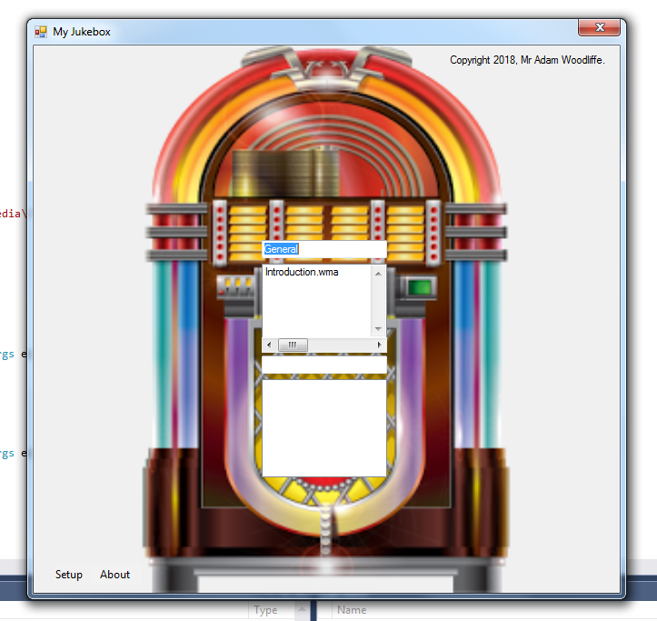

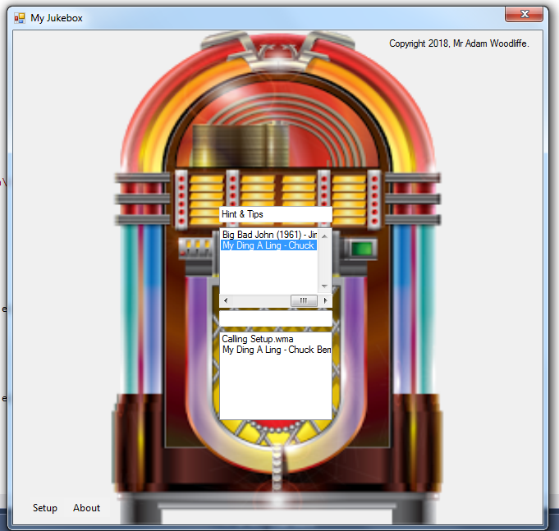

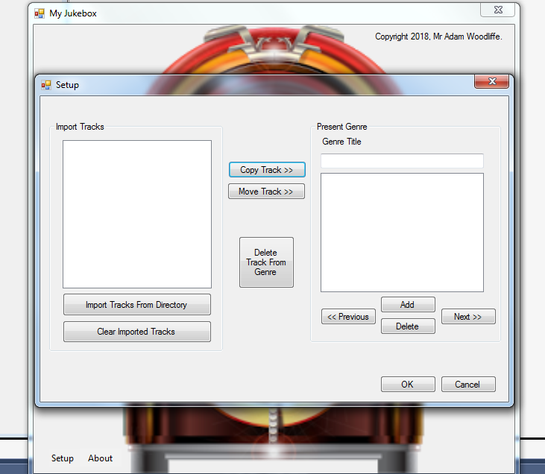

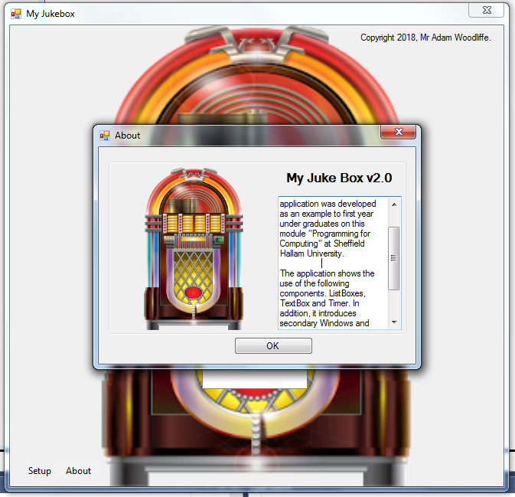

My GitHub username is woody91. //Adam Woodliffe b5018875

My .cs code.

using System;

using System.Collections.Generic;

using System.ComponentModel;

using System.Data;

using System.Drawing;

using System.Linq;

using System.Text;

using System.Threading.Tasks;

using System.Windows.Forms;

using System.IO;

namespace Jukebox_Assignment

{

public partial class Form1 : Form

{

string applicationPath = Directory.GetCurrentDirectory() + "\\Media\\"; //This locates where the file is.

ListBox[] Genre;

public Form1()

{

InitializeComponent();

}

private void setupToolStripMenuItem_Click(object sender, EventArgs e)

{

Setup Check = new Setup(); //This opens the Setup form.

Check.Show();

}

private void aboutToolStripMenuItem_Click(object sender, EventArgs e)

{

About Check = new About(); //This opens the About form.

Check.Show();

}

private void Form1_Shown(object sender, EventArgs e)

{

load_media(); //When form loads, complete load media.

}

private void load_media()

{

int num_gen; //The number of genres in the text file.

int num_track; //The number of tracks within the text file.

StreamReader myInputStream = File.OpenText(applicationPath + "Media.txt"); //Opens the text file to be read.

num_gen = Convert.ToInt32(myInputStream.ReadLine()); //this reads the number "3" from the text file and then converts it into an interger.

hScrollBar1.Maximum = num_gen - 1;

Genre = new ListBox[num_gen]; // Creates a new list box

for (int g = 0; g < num_gen; g++) // This Selects "g" Between 0 and above (++)

{

Genre[g] = new ListBox();

num_track = Convert.ToInt32(myInputStream.ReadLine()); // this converts to an integer

Genre[g].Items.Add(myInputStream.ReadLine());

for (int t = 0; t < num_track; t++)

{

Genre[g].Items.Add(myInputStream.ReadLine()); // Takes the items from textfile and adds to Genre

}

}

display_genres(0);

}

private void display_genres(int genre_displayed)

{

GenreTitleBox.Clear();

GenreTitleBox.Text = Genre[genre_displayed].Items[0].ToString();

GenreListBox.Items.Clear();

for (int t = 1; t < Genre[genre_displayed].Items.Count; t++)

{

GenreListBox.Items.Add(Genre[genre_displayed].Items[t]); // Displays the genre and items that come with it

}

}

private void hScrollBar1_Scroll(object sender, ScrollEventArgs e)

{

display_genres(hScrollBar1.Value); // Switches Between Genres

}

private void GenreListBox_SelectedIndexChanged(object sender, EventArgs e)

{

// Unused object. See Selecttrack below.

}

private void Selecttrack(object sender, EventArgs e)

{

if (GenreListBox.SelectedIndex > -1) // Selects items within GenreListBox above 0.

PlaylistListBox.Items.Add(GenreListBox.Text); // Copies Text In GenreListBox to PlaylistListBox

}

private void PlaylistListBox_SelectedIndexChanged(object sender, EventArgs e)

{

}

}

}

// 15 GITHUB SUBMISSIONS UPLOADED - WOODY91